**OOP’s Task**

**Python Assignment**

**9th Feb. 2023**

**Q1, Create a vehicle class with an init method having instance variables as name_of_vehicle, max_speed and average_of_vehicle.**

**Sol.**

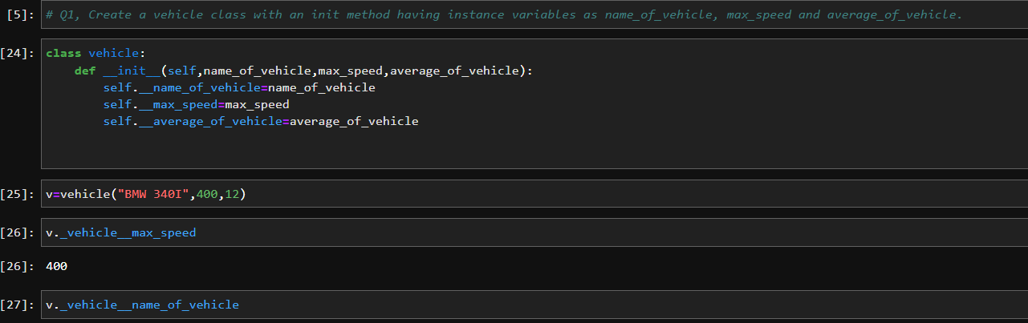

Q2. Create a child class car from the vehicle class created in Que 1, which will inherit the vehicle class. Create a method named seating_capacity which takes capacity as an argument and returns the name of the vehicle and its seating capacity.

Sol.

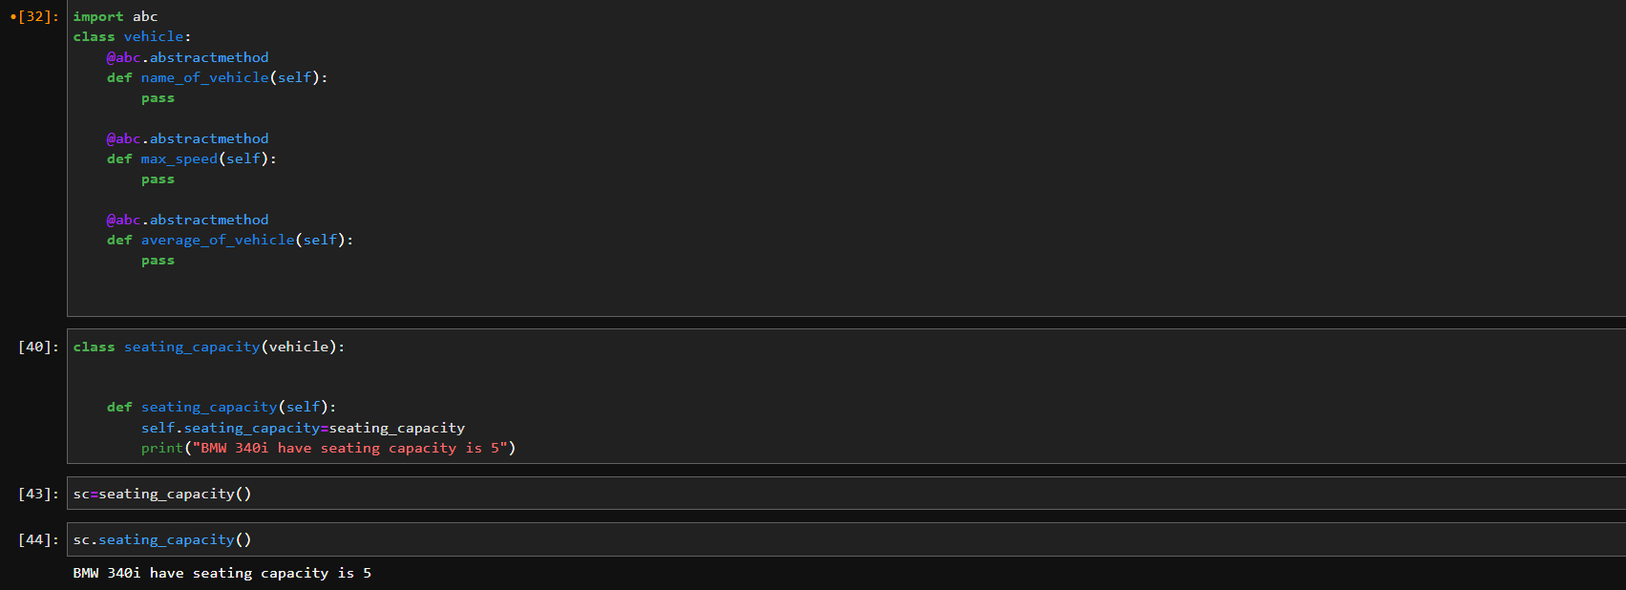

Q3. What is multiple inheritance? Write a python code to demonstrate multiple inheritance.

Sol.  If a child class is inheriting the properties of a single other class, we call it single inheritance. However, if a child class inherits from more than one class, i.e. this child class is derived from multiple classes, we call it **multiple inheritance in Python.** This newly derived child class will inherit the properties of all the classes that it is derived from.

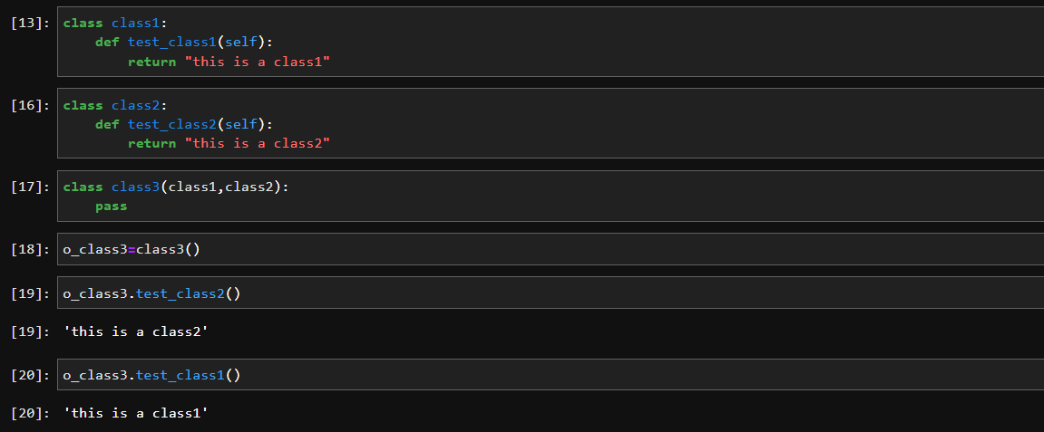

**Q4. What are getter and setter in python? Create a class and create a getter and a setter method in this class.**

**Sol. *Sorry***

**Q5.What is method overriding in python? Write a python code to demonstrate method overriding.**

**Sol.** Method overriding is an ability of any object-oriented programming language that allows a subclass or child class to provide a specific implementation of a method that is already provided by one of its super-classes or parent classes. When a method in a subclass has the same name, same parameters or signature and same return type(or sub-type) as a method in its super-class, then the method in the subclass is said to **override** the method in the super-class.

